
PROJECT 2

AI-Driven Phishing Email Detection Using Machine Learning and Text Classification



PROJECT REPORT

15TH June – 30THJuly 2026

Student Name: Kush Jain
Institute Name: Manipal University Jaipur
Institute ID: 23FE10CAI00398
Enrollment No: 567333

AI-Driven Phishing Email Detection Using Machine Learning and Text Classification
Kush Jain
Manipal University Jaipur
Institute Roll No.: 23FE10CAI00398 | Enrollment No.: 567333
Summer Internship Program in AI & ML — Project 1, Indian Institute of Computing and Technology (IICT)
Abstract
Phishing e-mails still constitute one of the widespread cyber threats to individuals and enterprises, trying to get sensitive information, such as passwords, financial information, and personal data. Manually finding these e-mails is challenging due to the growing level of sophistication of these attacks and their increasing frequency. The current project aims to develop an artificial intelligence-based detection system of phishing e-mails utilizing NLP and Machine Learning approaches. The proposed system preprocesses unstructured text data of e-mails, converts textual data into numeric features via TF-IDF technique, and builds four machine learning classifiers: Logistic Regression, Multinomial Naïve Bayes, Random Forest, and Multi-Layer Perceptron (Neural Network). The performance of the models is assessed by means of accuracy, precision, recall, F1-score, confusion matrices, and comparative performance analysis. The experimental analysis has shown that all four models are highly effective in classification, and Neural Network demonstrated the highest accuracy among all the models on the dataset at hand.

I. INTRODUCTION
The most popular type of attack is phishing, where the attacker impersonates some organization or individual and tries to trick the user into disclosing valuable information like passwords, bank credentials, and personal information. Given the growing popularity of email communication in the context of everyday life and work, phishing has grown increasingly sophisticated and is thus hard to distinguish manually from legitimate emails. Rule-based filtering has proven to be ineffective in detecting new emerging patterns of phishing, necessitating more intelligent approaches to detecting such attacks.
AI and ML combined with NLP can help detect phishing emails through learning hidden patterns from a collection of already-labeled emails. NLP allows processing text and understanding its meaning, while ML enables classifying emails based on linguistic features present in the text.
The ultimate goal of the project is to build a phishing email detection system that uses AI and machine learning techniques to categorize emails into two categories, Legitimate and Phishing. The entire workflow will consist of loading datasets, data cleaning, text preprocessing, TF-IDF-based feature extraction, training, performance evaluation, comparison, and saving trained models for predictions in the future.
Unlike the traditional approach, which focuses on detecting known signatures in emails, the presented solution focuses on the textual analysis of emails. Four different machine learning algorithms – Logistic Regression, Multinomial Naive Bayes, Random Forest, and Multi-Layer Perceptron were implemented and compared based on their performance using several evaluation criteria like Accuracy, Precision, Recall, F1-Score, and Confusion Matrix.
The presented project is the result of the internship in AI & ML, conducted by the Indian Institute of Computing and Technology (IICT). The implementation focuses on building an end-to-end machine learning pipeline with emphasis on simplicity and reproducibility.

The Role of Artificial Intelligence, machine Learning and NLP

AI facilitates automated email data analysis through reduction of human interaction in the process of detection. It allows learning patterns of phishing attacks and makes detection more efficient, rather than focusing only on security rules that have been created manually.

ML is the cornerstone of the system because it learns relations between textual features and classes of emails from labeled data. After being trained, the classifiers become capable of determining whether a new email is genuine or phishing.

NLP is needed to prepare the email text for machine learning algorithms, namely to convert it into the form suitable for learning. In this project, various NLP techniques will be applied including text cleaning, stopword removal, token processing, and TF-IDF vectorization.

B. Objectives of the Project

The major objectives of this project are:

To develop an AI-driven phishing email detection system using Machine Learning and Natural Language Processing.

To preprocess raw email text by removing unnecessary characters and stopwords.

To convert textual email content into numerical features using TF-IDF vectorization.

To train and compare Logistic Regression, Multinomial Naive Bayes, Random Forest, and Neural Network classifiers.

To evaluate model performance using Accuracy, Precision, Recall, F1-score, and Confusion Matrix.

To identify the best-performing model for phishing email classification.

To save the trained machine learning models for future prediction and deployment.

II. DATASET DESCRIPTION

The quality and diversity of the data employed for model training and testing greatly affect the performance of the machine learning algorithm. For this particular project, a dataset of phishing emails called phishing_email.csv was used for developing the proposed phishing email detection system. This dataset has emails collected from various publicly available sources and has both phishing and non-phishing emails. This data has been collected and preprocessed especially for the binary text classification problem, which means that each email will be of two types – Legitimate or Phishing.

Each row of the dataset consists of the full email message in the text_combined column, while the labels corresponding to the email type can be found in the label column. The labels of the emails are numerical and correspond to 0 if the email is legitimate or 1 if the email is phishing. As part of the data analysis process, the dataset has been checked for any missing values and duplicate emails. No missing values have been found, while the duplicate email rows have been removed in order to get higher-quality training data. After preprocessing, there have been about 82,000 emails in the dataset.

In preparing the dataset for modeling, it is important to note that only the body of each email message was selected as the sole input variable to the models. All other variables in the email message such as the details of the sender, presence of attachments, time stamping, and embedded links were not considered in the baseline design since the focus was purely on linguistic features of phishing attacks.

The dataset was then separated into a training set and a testing set in an 80/20 stratified split to ensure that the distribution of legitimate emails and phishing emails was consistent across the two splits. Further, textual data were converted to numerical vectors using TF-IDF.

Property | Value
Dataset Name | phishing_email.csv
Total Records (After Cleaning) | ~82,000
Input Feature | text_combined
Target Label | label
Legitimate Email | 0
Phishing Email | 1
Missing Values | 0
Duplicate Records | Removed
Train-Test Split | 80% Training / 20% Testing (Stratified)
Feature Representation | TF-IDF (Maximum 5000 Features)
Table I. Dataset Summary
Dataset Characteristics
The dataset contains textual information of varying lengths, ranging from short notification emails to lengthy business communications. Such diversity enables the machine learning models to learn representative patterns associated with both phishing and legitimate emails. Before feature extraction, the dataset underwent preprocessing operations including conversion to lowercase, removal of HTML tags, URLs, punctuation, numerical values, and English stopwords. These preprocessing steps reduced noise and improved the quality of the textual representation used for classification.
The dataset exhibited a relatively balanced distribution between legitimate and phishing emails after duplicate removal, reducing the risk of significant class imbalance during model training. This balanced distribution contributed to reliable model evaluation using standard performance metrics.
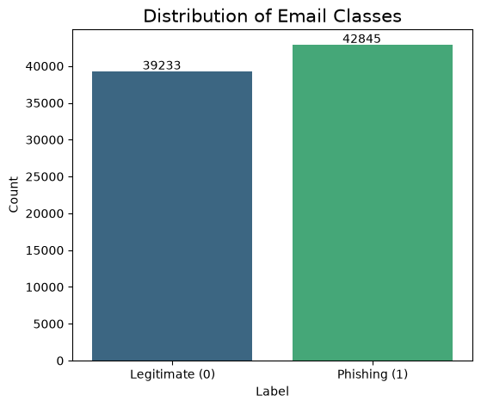
Fig. 1. Distribution of Legitimate and Phishing Emails
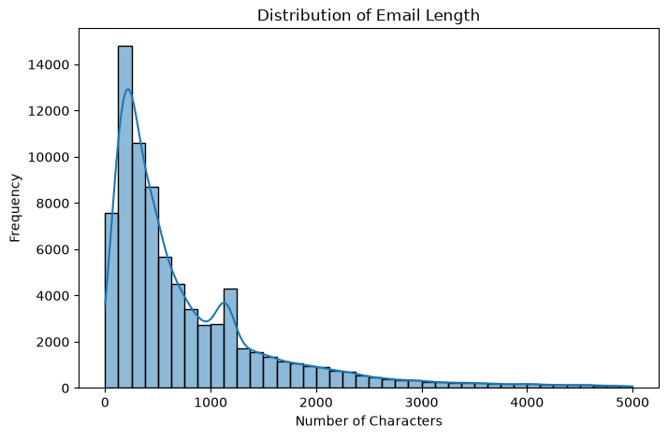
Fig. 2. Distribution of Email Text Length

III. METHODOLOGY

The suggested phishing email detection system uses the process of a typical machine learning pipeline which includes dataset collection, text preprocessing, features extraction, training of models, evaluation of models' performances, and saving the trained models. This pipeline is aimed at converting textual information contained in the emails into numerical values, which will be used in further processing by the machine learning algorithms in the form of a binary classification problem.

The pipeline used in this research is shown below:

Collection of Dataset

Preparation and Preprocessing of Data

Features Extraction via TF-IDF Method

Splitting of Train and Test Data

Training of Models

Evaluation of Models' Performance

Comparison of Models

Saving Trained Models

A. Preprocessing
However, raw email texts cannot be directly analyzed using machine learning models since the emails may contain some unnecessary symbols, formatting and unnecessary words. Thus, some preprocessing was done to convert the email text into a standard text format which would help in extracting features from it.
The following preprocessing tasks were performed:
- Conversion of the text to lowercase characters.
- Removal of HTML tags.
- Removal of URLs.
- Removal of numbers.
- Removal of punctuations and special characters.
- Removal of English stopwords.
- Removal of extra white spaces.
This helped in reducing the textual noise and ensured that only meaningful words were used in the process of learning. Post preprocessing, a new column known as 'clean_text' was created for each of the email texts.

B. Feature Extraction
Since machine learning algorithms need numeric values, the clean email data set was vectorized by means of the Term Frequency–Inverse Document Frequency (TF-IDF) approach.
The TF-IDF weighting method is based on the idea that words which often appear in a single document but not in other documents receive more weight.

The vectorizer was defined with the following parameters:
Parameter | Value
Method | TF-IDF
Max Features | 5000
Removal of Stop Words | English
Feature Output | Sparse Matrix of Features
This matrix of features was used as an input to the machine learning classifiers of the current work..

C. Train Test Split

After feature extraction, the dataset was divided into training and testing subsets using the train_test_split() function from Scikit-learn.

The dataset was partitioned as follows:
Property | Value
Training Data | 80%
Testing Data | 20%
Random State | 42
Stratification | Enabled

A stratified split was employed to preserve the proportion of legitimate and phishing emails in both subsets, ensuring fair model evaluation.

D. Machine Learning Models

To identify the most suitable classifier for phishing email detection, four supervised machine learning algorithms were implemented and compared. Each model was trained using the same TF-IDF feature representation and evaluated under identical experimental conditions.

1. Logistic Regression

Logistic Regression is a widely used linear classification algorithm for binary classification problems. It estimates the probability that an email belongs to either the legitimate or phishing class by learning a linear decision boundary from the TF-IDF feature vectors. Due to its simplicity and efficiency, Logistic Regression serves as a strong baseline model for text classification tasks.

2. Multinomial Naive Bayes

Multinomial Naive Bayes is a probabilistic classifier based on Bayes' theorem. It assumes conditional independence among textual features and is particularly effective for document and email classification tasks. Since TF-IDF captures the importance of words in each email, the Multinomial Naive Bayes classifier can efficiently distinguish phishing emails from legitimate ones.

3. Random Forest

Random Forest is an ensemble learning algorithm that combines multiple decision trees to improve classification accuracy and reduce overfitting. Each tree is trained using a different subset of the training data, and the final prediction is obtained through majority voting among all trees. This ensemble approach enables the classifier to capture more complex relationships within the dataset.

4. Neural Network (Multi-Layer Perceptron)

A simple Multi-Layer Perceptron (MLP) was implemented as the neural network model in this project. The network consists of an input layer, one hidden layer, and an output layer. During training, the network learns complex nonlinear relationships between TF-IDF features and email categories through iterative weight optimization. The MLP model was included to compare the performance of a neural network against traditional machine learning algorithms.

Algorithm | Category | Implementation
Logistic Regression | Linear Classifier | LogisticRegression
Multinomial Naive Bayes | Probabilistic Classifier | MultinomialNB
Random Forest | Ensemble Learning | RandomForestClassifier
Neural Network | Deep Learning | MLPClassifier

Table II. Machine Learning Models Implemented

E. Model Evaluation

The performance of each classifier was evaluated using commonly accepted classification metrics. These metrics provide a comprehensive assessment of the model's predictive capability and classification reliability.

The following evaluation metrics were used:

Accuracy: Measures the proportion of correctly classified emails.

Precision: Indicates the percentage of predicted phishing emails that were actually phishing.

Recall: Measures the ability of the model to correctly identify phishing emails.

F1-Score: Represents the harmonic mean of precision and recall.

Confusion Matrix: Visualizes the number of correctly and incorrectly classified legitimate and phishing emails.

These evaluation measures provide a balanced comparison of the strengths and weaknesses of each machine learning model.

F. Model Saving

After training and evaluation, all machine learning models and the TF-IDF vectorizer were saved using the Joblib library. Saving the trained models eliminates the need for retraining during future predictions and allows the phishing email detection system to be deployed or reused efficiently.

The following artifacts were generated:

tfidf_vectorizer.pkl

logistic_regression.pkl

naive_bayes.pkl

random_forest.pkl

neural_network.pkl

G. Algorithm 1. Proposed AI-Driven Phishing Email Detection Algorithm (Pseudocode)

Input:

Phishing email dataset (phishing_email.csv)

Output:

Predicted class (Legitimate / Phishing)

Trained machine learning models

Begin

1. Load phishing email dataset.

2. Perform data quality check:

• Remove duplicate records.

• Check for missing values.

3. Preprocess email text:

• Convert text to lowercase.

• Remove HTML tags.

• Remove URLs.

• Remove punctuation.

• Remove numbers.

• Remove stopwords.

• Store cleaned text.

4. Convert cleaned text into numerical features

using TF-IDF Vectorizer

(Maximum Features = 5000).

5. Split dataset into:

• Training Set (80%)

• Testing Set (20%)

6. Train the following classifiers:

a) Logistic Regression

b) Multinomial Naive Bayes

c) Random Forest

d) Neural Network (MLP)

7. Predict class labels on test data.

8. Evaluate each model using:

• Accuracy

• Precision

• Recall

• F1-Score

• Confusion Matrix

9. Compare model performances.

10. Select the best-performing model.

11. Save trained models and TF-IDF vectorizer

using Joblib.

End

Fig. 3. Overall Workflow of the Proposed Phishing Email Detection System

IV. RESULTS

The proposed method for detecting phishing emails was tested using four different supervised machine learning models: Logistic Regression, Multinomial Naive Bayes, Random Forest and Neural Network (Multilayer perceptron). All four models were trained using the same TF-IDF feature set and tested using the same testing dataset under the same experimental settings. The performance of the classifiers was analyzed in terms of Accuracy, Precision, Recall, F1-score and Confusion Matrix.

It can be seen from the experimental results that all four classifiers showed high classification performance when applied to the phishing email data set. The highest accuracy was achieved by the Neural Network classifier, followed by Logistic Regression and Random Forest classifiers.

A. Performance Comparison of Machine Learning Models
The evaluation metrics obtained from each classifier are summarized in Table III.
 | Model | Accuracy | Precision | Recall | F1-Score
0 | Logistic Regression | 0.979959 | 0.978291 | 0.983429 | 0.980853
1 | Naive Bayes | 0.959673 | 0.975695 | 0.946318 | 0.960782
2 | Random Forest | 0.977887 | 0.983274 | 0.974209 | 0.978721
3 | Neural Network | 0.982822 | 0.982195 | 0.984946 | 0.983568
Table III. Performance Comparison of Machine Learning Models

B. Accuracy Comparison
Figure 4 illustrates the accuracy achieved by all four machine learning models. The comparison indicates that the Neural Network obtained the highest classification accuracy among the implemented algorithms, while Logistic Regression and Random Forest also demonstrated strong predictive performance. Multinomial Naive Bayes achieved slightly lower accuracy but remained effective for phishing email classification.
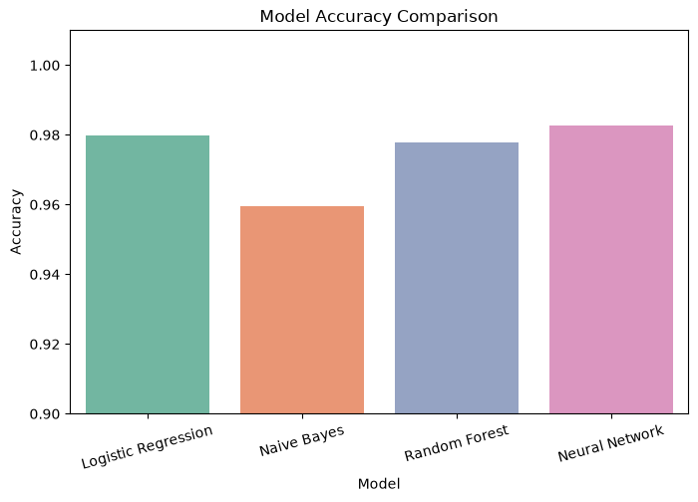
Fig. 4. Accuracy Comparison of Machine Learning Models
C. Precision, Recall, and F1-Score Analysis
Precision, Recall, and F1-score provide a more comprehensive assessment of model performance than accuracy alone. Precision evaluates the proportion of correctly identified phishing emails among all predicted phishing emails, whereas Recall measures the model's ability to detect actual phishing emails. The F1-score balances both Precision and Recall and is particularly useful for binary classification tasks.
The experimental results indicate that all implemented classifiers achieved consistently high Precision, Recall, and F1-score values, demonstrating their capability to distinguish legitimate emails from phishing emails with high reliability.
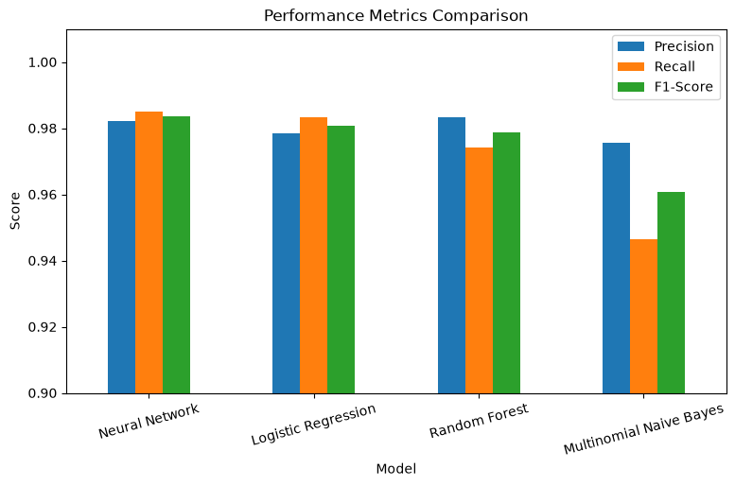
Fig. 5. Comparison of Precision, Recall, and F1-Score

D. Confusion Matrix Analysis
Confusion matrices were generated for each classifier to visualize the classification results.
The confusion matrices indicate that the majority of legitimate and phishing emails were classified correctly, with only a small number of misclassifications. The Neural Network exhibited the lowest number of false predictions, resulting in the highest overall classification performance. Logistic Regression and Random Forest also produced highly accurate confusion matrices, while Multinomial Naive Bayes showed slightly more false positives and false negatives.
Include the following figures:
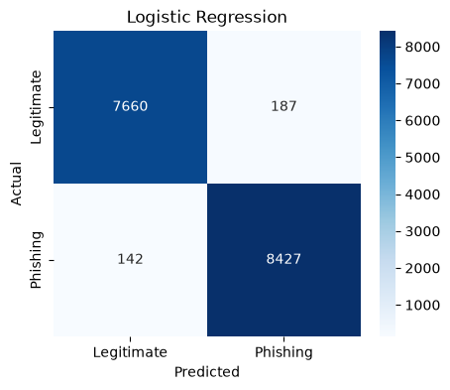
Fig. 6. Confusion Matrix – Logistic Regression

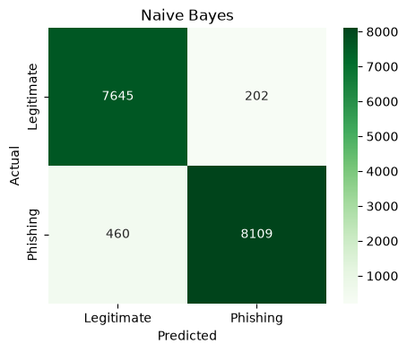
Fig. 7. Confusion Matrix – Multinomial Naive Bayes

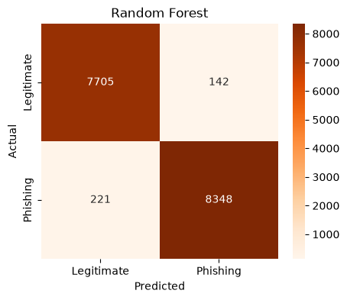
Fig. 8. Confusion Matrix – Random Forest

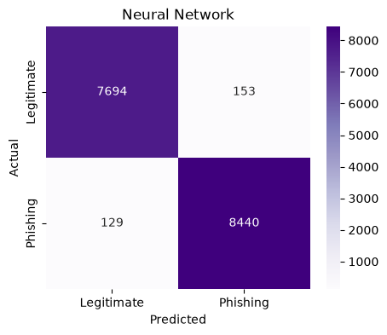
Fig. 9. Confusion Matrix – Neural Network

E. Best Performing Model
Based on the comparative analysis, the Neural Network (Multi-Layer Perceptron) achieved the highest overall performance among the implemented classifiers. The model consistently produced superior values for Accuracy, Precision, Recall, and F1-score, indicating its ability to effectively capture complex textual patterns associated with phishing emails. Consequently, the Neural Network was selected as the final model for the proposed phishing email detection system.

V. DISCUSSION

Experimental results confirm that machine learning approaches together with NLP can be considered extremely efficient for phishing email classification. All developed classifiers were able to learn semantic information from the TF-IDF text representation and showed excellent results during the process of classification on the testing dataset. Each of the compared algorithms has its own strengths and weaknesses, and the obtained results helped in analyzing the suitability of such approaches for phishing email classification.

Logistic regression was chosen as an example of a good baseline classifier due to its simplicity, computational efficiency, and ability to handle high-dimensional and sparse text data, created via the process of TF-IDF vectorization. The model trained a linear decision boundary that successfully separated legitimate and phishing emails. Thus, the performance of the model was very good.

Multinomial Naive Bayes algorithm also showed competitive performance despite the assumption that features in the text are conditionally independent. Such algorithm is used quite often in the field of text classification due to its low computational complexity and fast training time. Despite slightly lower performance compared to the other models, the algorithm was also very efficient for phishing email classification.

With the help of Random Forest algorithm, it was possible to boost classification results due to applying ensemble learning technique and averaging out decisions of several decision trees. The approach helped to find more complex relationships between the dataset elements without increasing the risk of overfitting, which is typical of a single decision tree. However, in comparison with linear algorithms, Random Forest required more computational power and time for training.

In general, Neural Network (Multi-Layer Perceptron) turned out to be the most successful among all considered models. It was able to learn complex nonlinear relationships in the TF-IDF feature space to achieve the best accuracy in classification of phishing and normal emails. It was the ability of modeling complex textual patterns that helped to improve the metrics of Precision, Recall, and F1-score.

It should be said that the preprocessing stage played an important part in the overall effectiveness of the system. The conversion of text to lowercase, removal of URLs, HTML tags, punctuation, numerical values, and stopwords helped to clean the text and improve its quality. The use of TF-IDF vectorizer helped to put emphasis on discriminative words in feature space.

Despite the fact that the received results seem very promising, there are some limitations associated with the proposed system. All the models use only textual data, ignoring other aspects of emails, such as the reputation of senders, URLs, domains, attachments, or email headers. Additionally, attackers may use obfuscation techniques or AI-generated phishing content, which can decrease the efficiency of purely textual approaches. Consequently, in the future, phishing detection algorithms need to incorporate textual, structural, and behavioral features to achieve better performance and generalization.

In summary, the conducted comparison shows that the proposed machine learning pipeline is an efficient and applicable approach to detect phishing emails. The research proves the application of NLP and supervised learning in dealing with cybersecurity problems and serves as the basis for future developments and implementation.

VI. CONCLUSION

In this project, an automatic phishing email detection algorithm based on Natural Language Processing and Machine Learning approaches has been proposed. The entire pipeline of the project has been developed including dataset loading and preprocessing, TF-IDF feature extraction, training and testing the models, performance evaluation, comparison of the models, and saving the models for future predictions.

There are four machine learning algorithms which include Logistic Regression, Multinomial Naive Bayes Classifier, Random Forest Classifier, and Neural Network (Multi-Layer Perceptron). All these models have been implemented and evaluated using Accuracy, Precision, Recall, F1-score, and Confusion Matrix. From the comparative analysis, it can be seen that all four classifiers perform well in terms of classification on this particular phishing email dataset. Moreover, Neural Network gives the best performance among the four models.

This algorithm is able to differentiate between phishing emails and legitimate emails using some significant textual features from the body of the email. The implementation of TF-IDF vectorizer along with supervised machine learning gives an efficient way of detecting phishing emails. The trained models have been saved using Joblib module.

This system gives a robust academic solution to phishing emails and shows the efficiency of using NLP and machine learning algorithms for cybersecurity applications.

The future scope of research may include adding more metadata features of an email such as sender, URLs, domain reputation, and even attachments. Moreover, the use of transformers as deep learning models, such as BERT, RoBERTa, and DistilBERT, can be investigated to utilize context better.

VII. APPENDIX

A. Software and Development Environment

The phishing email detection system was developed using Python and Jupyter Notebook. All machine learning models and data preprocessing operations were implemented using open-source Python libraries. The experimental setup is summarized in Table IV.

Component | Specification
Programming Language | Python 3.13
Development Environment | Jupyter Notebook
Operating System | Windows 11
Machine Learning Library | Scikit-learn
Data Manipulation | Pandas, NumPy
NLP Library | NLTK
Visualization | Matplotlib, Seaborn
Model Saving | Joblib

Table IV. Software Environment

B. Python Libraries Used

The following Python libraries were used during the implementation of the phishing email detection system.

pandas

numpy

matplotlib

seaborn

nltk

scikit-learn

joblib

re

string

warnings

C. Generated Project Files
After successful execution of the notebook, the following project files were generated.

File Name | Description
AI_Driven_Phishing_Email_Detection.ipynb | Complete implementation notebook
phishing_email.csv | Dataset
tfidf_vectorizer.pkl | Saved TF-IDF vectorizer
logistic_regression.pkl | Logistic Regression model
naive_bayes.pkl | Multinomial Naive Bayes model
random_forest.pkl | Random Forest model
neural_network.pkl | Neural Network model

VIII. REFERENCES

[1] J. Ramos, "Using TF-IDF to Determine Word Relevance in Document Queries," Proceedings of the First Instructional Conference on Machine Learning, 2003.

[2] F. Pedregosa et al., "Scikit-learn: Machine Learning in Python," Journal of Machine Learning Research, vol. 12, pp. 2825–2830, 2011.

[3] L. Breiman, "Random Forests," Machine Learning, vol. 45, no. 1, pp. 5–32, 2001.

[4] C. M. Bishop, Pattern Recognition and Machine Learning. Springer, 2006.

[5] T. M. Mitchell, Machine Learning. McGraw-Hill, 1997.

[6] S. Russell and P. Norvig, Artificial Intelligence: A Modern Approach, 4th ed. Pearson, 2021.

[7] Indian Institute of Computing and Technology (IICT), "Project 2: AI-Driven Phishing Email Detection Using NLP," AI & ML Summer Internship Project Brief, 2026.

[8] NLTK Project, "Natural Language Toolkit Documentation."

[9] Pandas Development Team, "Pandas: Python Data Analysis Library."

[10] NumPy Developers, "NumPy Reference Guide."

